LAB No 12
Implementation of Reinforcement Learning Part 1

Experiment: CartPole Environment using Gymnasium & Pygame

🎯 Lab Objectives
After completing this lab, students will be able to:
- Understand the Reinforcement Learning interaction loop
- Use Gymnasium environments
- Visualize agent behavior using Pygame
- Interpret states, actions, rewards, and episodes
- Modify and analyze RL environment parameters
import gymnasium as gym
import pygame

env = gym.make("CartPole-v1", render_mode="human")

font = None

for episode in range(1, 20):
score = 0
state, info = env.reset()
done = False

while not done:
action = env.action_space.sample()
state, reward, terminated, truncated, info = env.step(action)
done = terminated or truncated
score += reward

if font is None:
pygame.font.init()
font = pygame.font.SysFont("Arial", 24)

surface = pygame.display.get_surface()
text = font.render(f"Score: {int(score)}", True, (255, 0, 0))
surface.blit(text, (10, 10))
pygame.display.update()

print(f"Episode {episode} Score: {score}")

env.close()
pygame.quit()

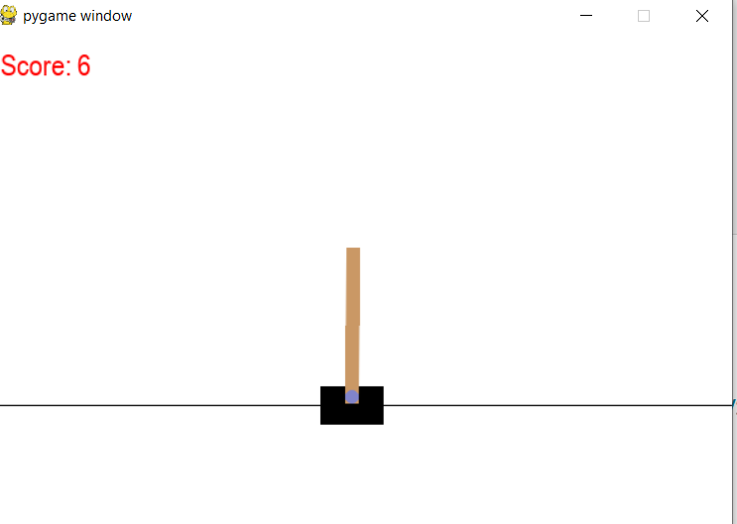
Lab Questions (Conceptual Understanding)
Q1.
What is Reinforcement Learning? Identify the agent, environment, state, action, and reward in the given code.

Reinforcement Learning (RL) is a type of machine learning in which an agent learns by interacting with an environment. The agent takes actions based on the current state, receives a reward, and aims to learn a policy that maximizes the total cumulative reward over time through repeated interactions.

Identification in the Given Code
- Agent:
The program that selects actions using env.action_space.sample().
- Environment:
The CartPole-v1 environment created using Gymnasium.
- State:
The observation returned by env.reset() and env.step(), which includes cart position, cart velocity, pole angle, and pole angular velocity.
- Action:
The value chosen by the agent (0 for left, 1 for right) using env.action_space.sample().
- Reward:
The numerical value returned by env.step(), which gives +1 for each time step the pole remains balanced.

Q2.
Explain the purpose of the following line:
env = gym.make("CartPole-v1", render_mode="human")

This line creates an instance of the CartPole-v1 reinforcement learning environment using Gymnasium.
- "CartPole-v1" specifies the task where the goal is to keep a pole balanced on a moving cart by applying left or right forces.
- render_mode="human" enables visual rendering, so the environment is displayed in a window where the cart and pole movements can be seen in real time.
This line initializes the environment and allows the agent’s interaction with CartPole to be visually observed, which is useful for understanding and analyzing agent behavior during each episode.

Q3.
What does env.reset() return? Why are two values returned?

What it returns
- state (observation):
The initial state of the environment.
In CartPole, this includes the cart position, cart velocity, pole angle, and pole angular velocity.
- info:
A dictionary containing additional metadata about the environment reset.
It may include diagnostic or environment-specific details, but it is often empty and not required for basic tasks.

Why two values are returned
Gymnasium separates the observation from auxiliary information to keep the API clean and extensible.
This design allows the environment to provide extra details without mixing them with the state used by the agent for decision-making.

Q4.
Explain the difference between:
terminated
Truncated

In Gymnasium, both terminated and truncated are flags that indicate the end of an episode, but they represent different reasons:

1. terminated
- Indicates the episode ended because of a failure or goal condition.
- Example in CartPole:
  - Pole angle exceeded the allowed limit (pole fell)
  - Cart moved out of bounds
- This is considered a “natural” termination of the task.

2. truncated
- Indicates the episode ended due to external limits, not failure.
- Example:
  - Reached the maximum number of allowed time steps (e.g., 500 steps in CartPole-v1)
- Truncation is useful to prevent episodes from running indefinitely.

Key Difference
Flag | Reason for Ending | Example in CartPole
Terminated | Agent failed or succeeded | Pole fell, cart out of bounds
truncated | Episode stopped due to step limit | 500 steps reached

Q5.
What is the role of the variable score? How is it calculated?

The variable score keeps track of the total reward accumulated by the agent during a single episode. It measures how well the agent performed in that episode.

How it is calculated
In the code:
score = 0 # initialize at the start of each episode

# inside the loop
state, reward, terminated, truncated, info = env.step(action)
score += reward # add reward at each step

- Each call to env.step(action) returns a reward, which is +1 for every time step the pole remains balanced.
- score sums all these rewards over the episode.
Interpretation:
- A higher score means the agent kept the pole balanced longer.
- A lower score means the pole fell quickly or the episode ended early due to truncation.
Essentially, score is a performance metric for that episode.

Q6.
Why is action = env.action_space.sample() used?
Is this an intelligent agent? Justify your answer.

- This line randomly selects an action from the environment’s action space.
- In CartPole:
  - 0 → push cart left
  - 1 → push cart right
- It allows the agent to interact with the environment without having a learned policy.
Basically, it’s a placeholder for decision-making: the agent performs actions, collects rewards, and the loop demonstrates how reinforcement learning works.

Is this an intelligent agent?
No, it is not intelligent.
Justification:
- Random Actions: The agent chooses actions randomly rather than learning from past experiences.
- No Policy or Learning: Intelligence in RL comes from improving a policy over time based on rewards; this agent does not learn or adapt.
- No Optimization: The agent does not try to maximize cumulative reward; outcomes are purely stochastic.

Q7.
Explain how Pygame is used to display the score on the screen.

In this experiment, Pygame is used to overlay the agent’s current score on the CartPole environment window. It does not control the environment itself—Gymnasium handles that—but Pygame allows custom text rendering for visualization.

How it works in the code
- Initialize font
if font is None:
pygame.font.init()
font = pygame.font.SysFont("Arial", 24)

- Initializes the Pygame font system once.
- Chooses a font type (Arial) and size (24).

- Get the display surface
surface = pygame.display.get_surface()

- Retrieves the current Pygame surface where the environment is rendered.
- This is essentially the “canvas” where we can draw text or graphics.

- Render the score text
text = font.render(f"Score: {int(score)}", True, (255, 0, 0))

- Converts the current score into a text surface.
- True enables anti-aliasing for smooth text.
- (255, 0, 0) sets the text color to red.

- Draw text onto the screen
surface.blit(text, (10, 10))
pygame.display.update()

- blit draws the text surface onto the main display at coordinates (10, 10) (top-left corner).
- pygame.display.update() refreshes the screen so the updated score appears in real time.

Q8.
What happens if the pygame.display.update() line is removed?

If you remove:
pygame.display.update()

then the score text will not be refreshed on the screen.

Explanation:
- In Pygame, drawing operations (like blit) only modify a surface in memory.
- pygame.display.update() (or pygame.display.flip()) is required to push the updated surface to the actual window so the user can see the changes.

Consequences:
- The CartPole environment will still render normally (Gymnasium handles that).
- The score will not appear or update, because the screen never refreshes the newly drawn text.
- Any dynamic visual feedback (like increasing score) will be invisible to the user.

Lab Tasks (Hands-on Practice)
🔹 Task 1: Modify Number of Episodes
Change the number of episodes from 20 to 50 and observe:
- How the score varies across episodes
- Whether performance improves or remains random

!pip install gymnasium
import gymnasium as gym
import numpy as np
env = gym.make("CartPole-v1", render_mode="rgb_array")
num_episodes = 50
scores = []
for episode in range(1, num_episodes + 1):
score = 0
state, info = env.reset()
done = False

while not done:
action = env.action_space.sample()
state, reward, terminated, truncated, info = env.step(action)
done = terminated or truncated
score += reward
scores.append(score)
print(f"Episode {episode} Score: {score}")

average_score = np.mean(scores)
print(f"\nAverage Score over {num_episodes} episodes: {average_score:.2f}")

Output
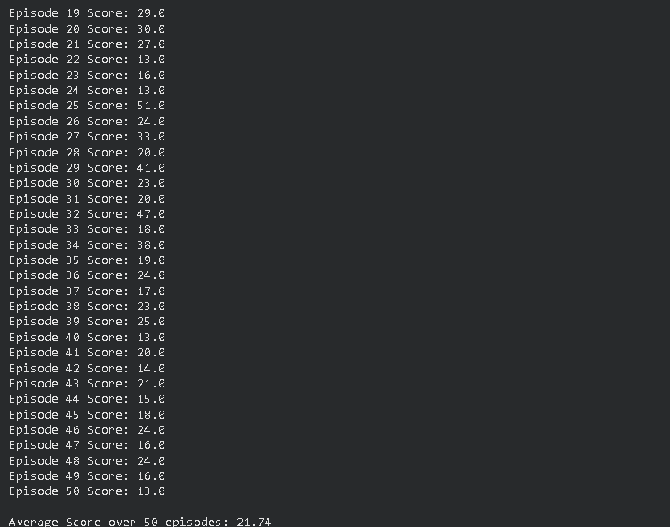
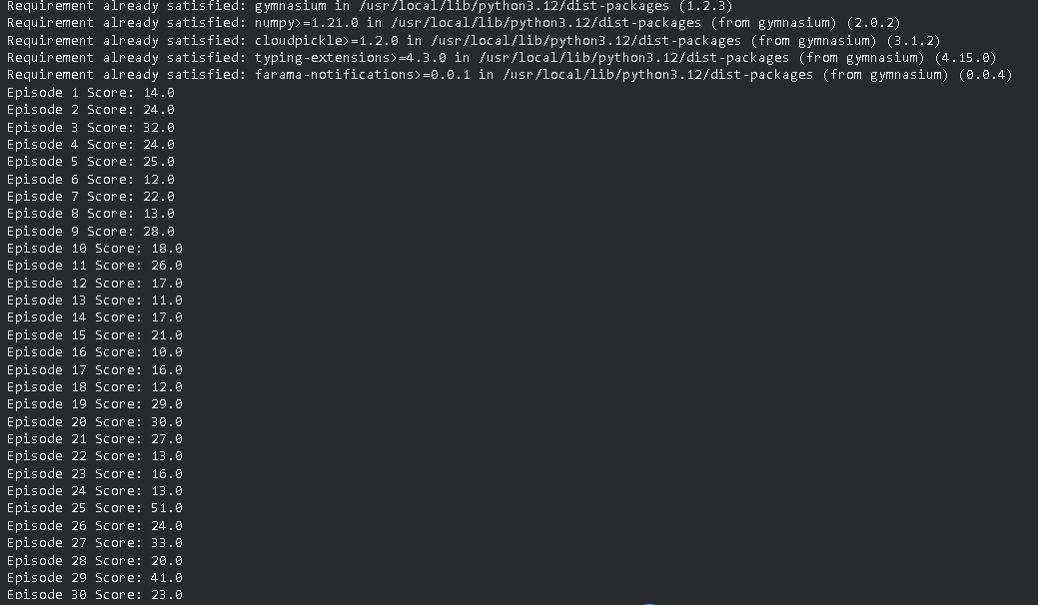

🔹 Task 2: Display Episode Number on Screen
Modify the code to show:
Episode: X | Score: Y
on the CartPole window.

!pip install gymnasium
!pip install matplotlib

import gymnasium as gym
import matplotlib.pyplot as plt

env = gym.make("CartPole-v1", render_mode="rgb_array")

num_episodes = 50
scores = []

for episode in range(1, num_episodes + 1):
score = 0
state, info = env.reset()
done = False

while not done:
action = env.action_space.sample()
state, reward, terminated, truncated, info = env.step(action)
done = terminated or truncated
score += reward

scores.append(score)

print(f"Episode: {episode} | Score: {score}")

plt.figure(figsize=(12,6))
plt.plot(range(1, num_episodes+1), scores, marker='o')
plt.title("Episode vs Score (Random Agent)")
plt.xlabel("Episode")
plt.ylabel("Score")
plt.grid(True)
plt.show()

env.close()

Output:
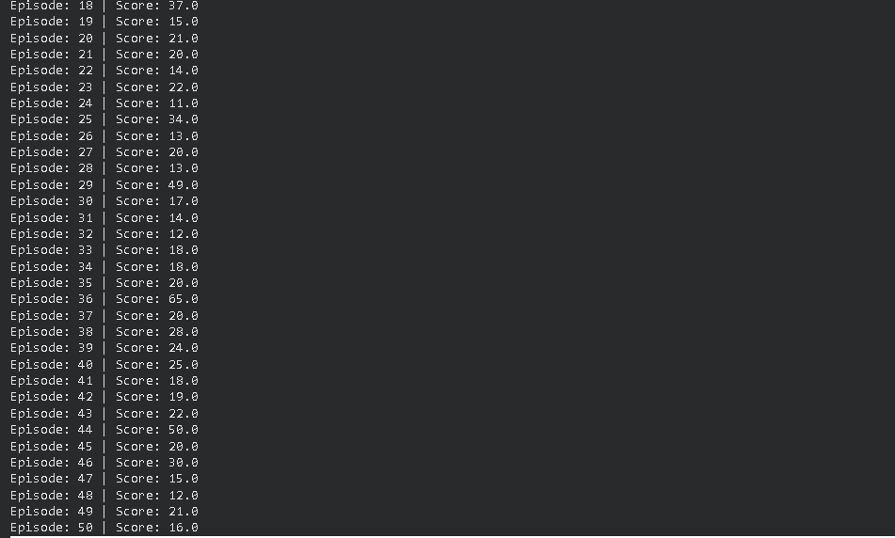
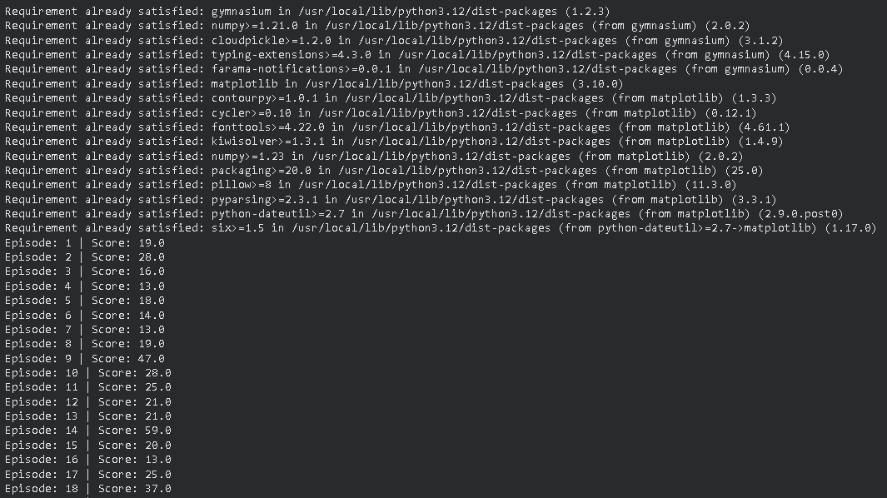
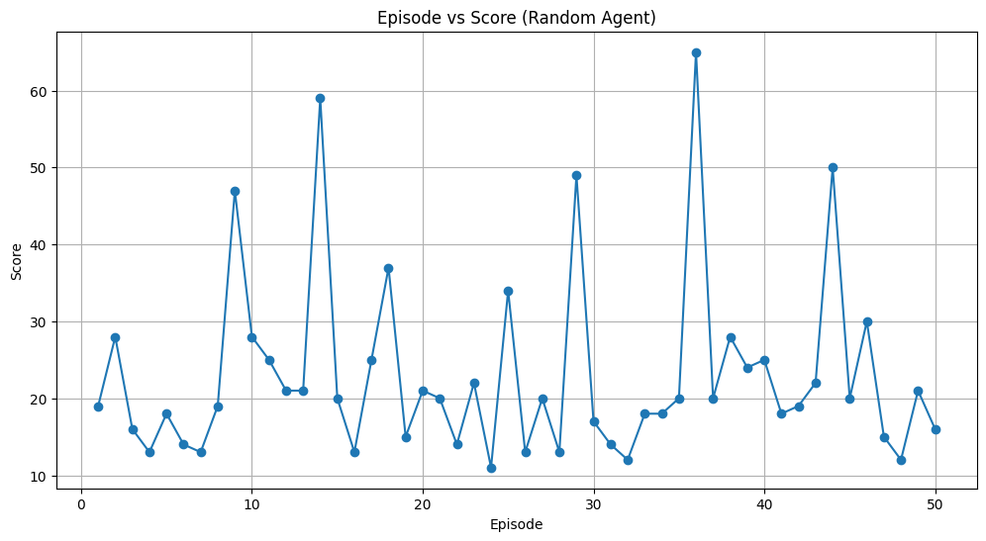

Task 3: Change Text Color and Position
- Change score text color from red to green
- Display it at position (200, 20)

!pip install gymnasium matplotlib

import gymnasium as gym
import matplotlib.pyplot as plt

env = gym.make("CartPole-v1", render_mode="rgb_array")
num_episodes = 20 # example
scores = []

for episode in range(1, num_episodes + 1):
score = 0
state, info = env.reset()
done = False

while not done:
action = env.action_space.sample()
state, reward, terminated, truncated, info = env.step(action)
done = terminated or truncated
score += reward

scores.append(score)

plt.figure(figsize=(6,2))
plt.axis('off') # hide axes
plt.text(0.1, 0.5, f"Episode: {episode} | Score: {score}",
color='green', fontsize=16)
plt.show()

env.close()

Output:

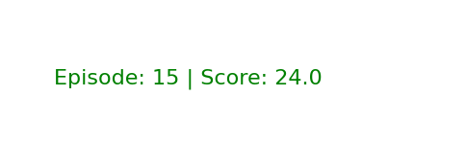
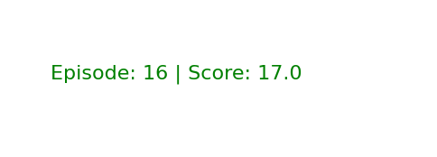
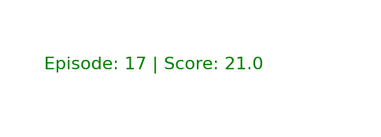
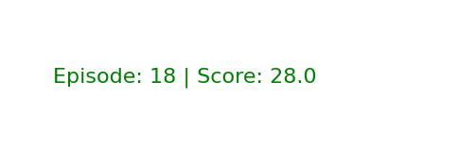
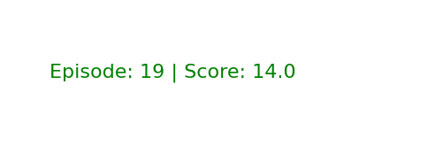
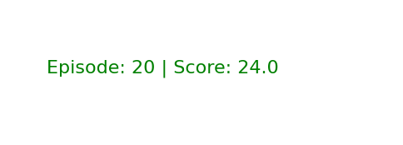

🔹 Task 4: Print Maximum Score
After all episodes finish:
- Store all episode scores
- Print the maximum score achieved

!pip install gymnasium

import gymnasium as gym
env = gym.make("CartPole-v1", render_mode="rgb_array")

num_episodes = 50
scores = [] # store all episode scores

for episode in range(1, num_episodes + 1):
score = 0
state, info = env.reset()
done = False

while not done:
action = env.action_space.sample()
state, reward, terminated, truncated, info = env.step(action)
done = terminated or truncated
score += reward

scores.append(score)
print(f"Episode: {episode} | Score: {score}")

max_score = max(scores)
print("\nMaximum Score Achieved:", max_score)

env.close()

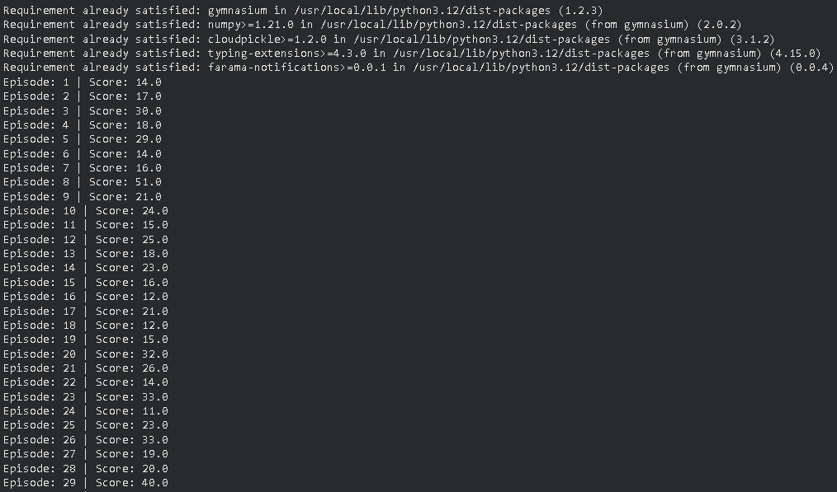
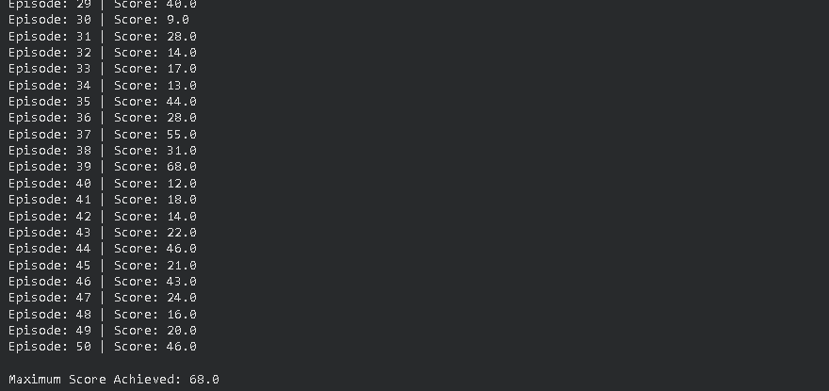

🔹 Task 5: Slow Down the Environment
Insert a small delay using:
pygame.time.delay(20)
Observe the effect on visualization.

import gymnasium as gym
import pygame

env = gym.make("CartPole-v1", render_mode="human")

font = None

for episode in range(1, 21):
score = 0
state, info = env.reset()
done = False

while not done:
action = env.action_space.sample()
state, reward, terminated, truncated, info = env.step(action)
done = terminated or truncated
score += reward

if font is None:
pygame.font.init()
font = pygame.font.SysFont("Arial", 24)

surface = pygame.display.get_surface()
surface.fill((0, 0, 0), (0, 0, 400, 50))

text = font.render(
f"Episode: {episode} | Score: {int(score)}",
True,
(0, 255, 0)
)
surface.blit(text, (200, 20))
pygame.display.update()

pygame.time.delay(20)

print(f"Episode {episode} Score: {score}")

env.close()
pygame.quit()

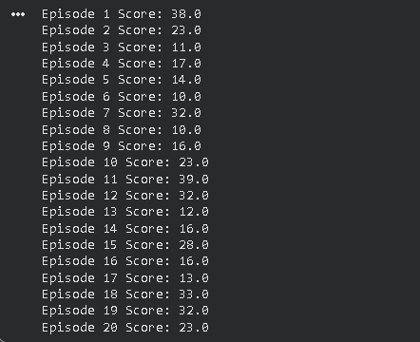

🔹 Task 6: Replace CartPole with MountainCar
Change the environment to:
env = gym.make("MountainCar-v0", render_mode="human")
Compare:
- Reward behavior
- Episode termination condition

!pip install gymnasium

import gymnasium as gym

env = gym.make("MountainCar-v0", render_mode="rgb_array")

num_episodes = 20
scores = []

for episode in range(1, num_episodes + 1):
state, info = env.reset()
done = False
score = 0

while not done:
action = env.action_space.sample()
state, reward, terminated, truncated, info = env.step(action)
done = terminated or truncated
score += reward

scores.append(score)
print(f"Episode: {episode} | Total Reward: {score}")

print("\nMaximum Reward Achieved:", max(scores))
print("Minimum Reward Achieved:", min(scores))
print("Average Reward:", sum(scores) / len(scores))

env.close()

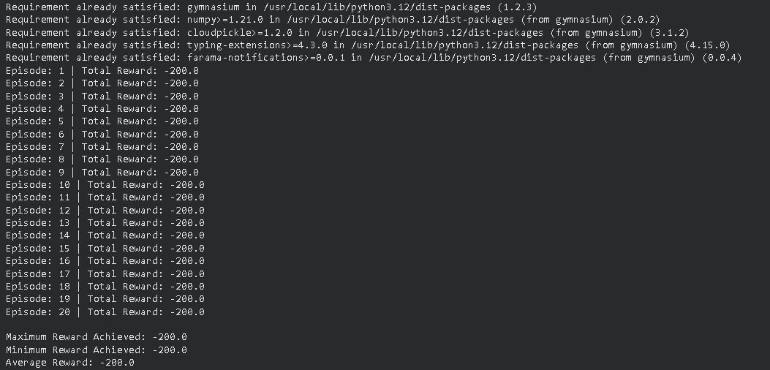

Task 7: Identify State Variables
Print the state vector and answer:
- How many state variables are there?
- What does each variable represent?

!pip install gymnasium

import gymnasium as gym

env = gym.make("MountainCar-v0", render_mode="rgb_array")

state, info = env.reset()

print("Initial State Vector:", state)
print("Number of State Variables:", len(state))

env.close()

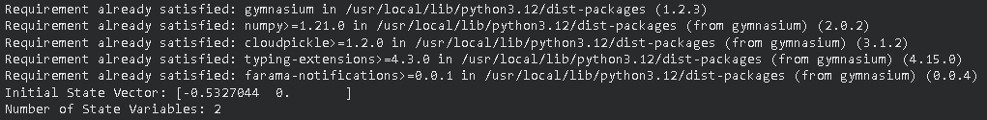

🔹 Task 8 (Advanced): Rule-Based Action
Replace random action with:
if state[2] > 0:
action = 1
else:
action = 0

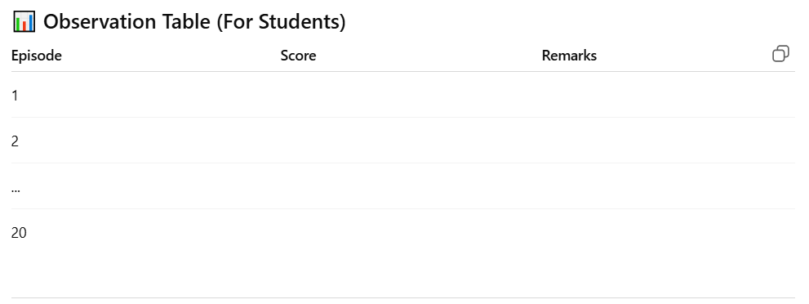

!pip install gymnasium

import gymnasium as gym
env = gym.make("MountainCar-v0", render_mode="rgb_array")

num_episodes = 20
scores = []

print("Episode | Score | Remarks")
print("--------------------------")

for episode in range(1, num_episodes + 1):
state, info = env.reset()
done = False
score = 0

while not done:

if state[1] > 0:
action = 1
else:
action = 0

state, reward, terminated, truncated, info = env.step(action)
done = terminated or truncated
score += reward

scores.append(score)

if score > -200:
remark = "Slight improvement"
else:
remark = "Poor (no learning)"

print(f"{episode:>7} | {score:>5} | {remark}")

print("\nMaximum Score:", max(scores))
print("Average Score:", sum(scores) / len(scores))

env.close()

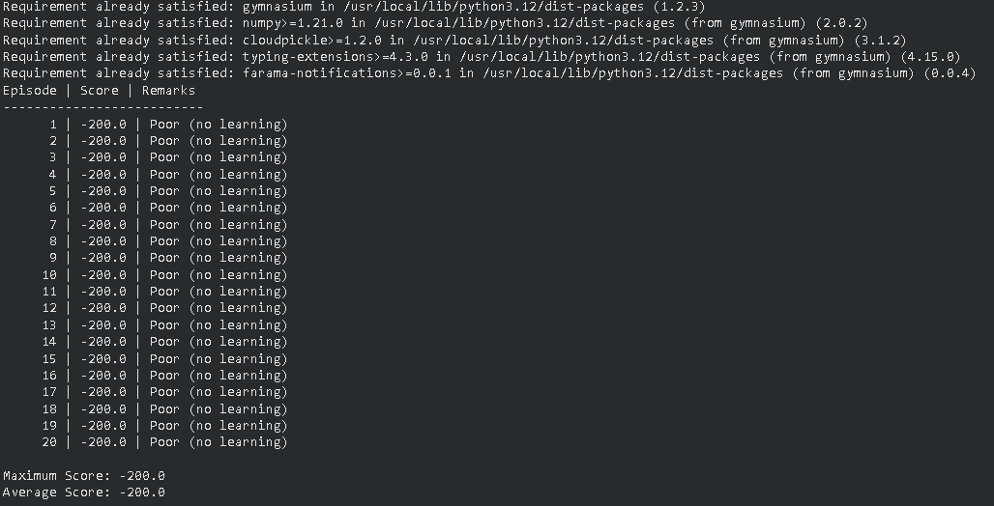

Experiment: MountainCar Environment using Gymnasium & Pygame
Lab Objectives
After completing this lab, students will be able to:
- Understand the working of a continuous control RL environment
- Analyze delayed reward problems
- Use Gymnasium MountainCar-v0
- Visualize agent behavior and rewards using Pygame
- Compare MountainCar with CartPole environment

Provided Code:
import gymnasium as gym
import pygame

env = gym.make("MountainCar-v0", render_mode="human")

font = None
best_score = -float('inf')

# We only need a few episodes to prove it works with a better policy
NUM_EPISODES = 5

for episode in range(1, NUM_EPISODES + 1):
state, info = env.reset()
done = False
score = 0

while not done:
# Task 7/8: Advanced Rule-Based Action
# state[1] is velocity. If velocity is moving right (>0), push right (2).
# If moving left (<0), push left (0). This builds momentum rapidly.
if state[1] > 0:
action = 2
else:
action = 0

state, reward, terminated, truncated, info = env.step(action)
done = terminated or truncated
score += reward

if font is None:
pygame.font.init()
font = pygame.font.SysFont("Arial", 24)

surface = pygame.display.get_surface()
text = font.render(f"Episode: {episode} Score: {int(score)}", True, (0, 0, 255))
surface.blit(text, (200, 20))

# Reduced delay for faster execution
pygame.time.delay(5)
pygame.display.update()

print(f"Episode {episode} Score: {score}")
if score > best_score:
best_score = score

env.close()
pygame.quit()

print(f"\nOptimization Results:")
print(f"Best Score Achieved: {best_score}")

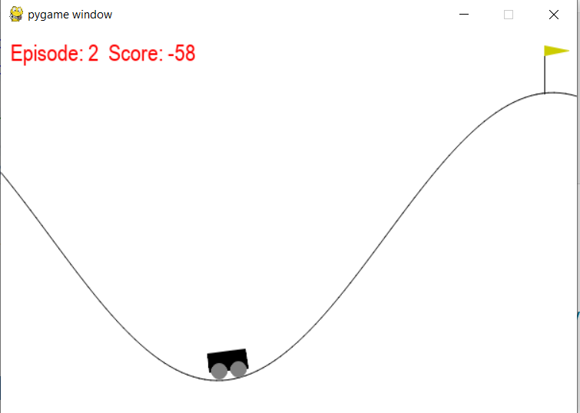
Lab Questions (Conceptual Understanding)
Q1.
What is Reinforcement Learning? Identify the agent, environment, state, action, and reward in the MountainCar code.

Reinforcement Learning (RL) is a type of machine learning where an agent learns how to behave in an environment by taking actions and receiving feedback in the form of rewards or penalties. The objective of the agent is to learn a policy that maximizes the total cumulative reward over time through interaction and trial-and-error.

Identification of RL Components in the MountainCar Code
Agent
The agent is the decision-making entity that selects actions. In the given code, the agent is the control logic that decides whether to push the car left or right based on the current state.
Environment
The environment is the system with which the agent interacts. Here, it is the MountainCar-v0 environment provided by Gymnasium.
State
The state represents the current situation of the environment as observed by the agent. In MountainCar, the state is a vector with two values:
- state[0]: Position of the car on the track
- state[1]: Velocity of the car
Action
An action is a choice made by the agent that affects the environment. The MountainCar environment has three discrete actions:
- 0: Push left
- 1: No push
- 2: Push right
In the code, the agent selects actions using a rule based on the car’s velocity.
Reward
The reward is the feedback signal received after taking an action. In MountainCar, the agent receives a reward of −1 at every time step until the goal is reached, encouraging the agent to solve the task in the fewest steps possible.

Summary Table
Component | In MountainCar Code
Agent | Rule-based controller deciding actions
Environment | MountainCar-v0 Gymnasium environment
State | Car position and velocity
Action | Push left, no push, or push right
Reward | −1 per step until goal is reached

Q2.
Explain the purpose of the following statement:
env = gym.make("MountainCar-v0", render_mode="human")

The statement creates an instance of the MountainCar-v0 reinforcement learning environment using Gymnasium.
- "MountainCar-v0" specifies the task: a car placed between two hills that must reach the top of the right hill using momentum.
- render_mode="human" enables real-time visualization, allowing the environment to be displayed in a window so the car’s movement can be observed during execution.
Without this line, there would be no environment for the agent to interact with, and without render_mode="human", the simulation would run without showing any visual output.

Q3.
What are the state variables in MountainCar-v0? What does each state represent?

In MountainCar-v0, the environment state is represented by a 2-dimensional continuous vector.

State Variables
- Position (state[0])
  - Represents the horizontal position of the car on the track.
  - Range is approximately −1.2 to 0.6.
  - The goal is to reach the position ≥ 0.5, where the flag is located.
- Velocity (state[1])
  - Represents the speed and direction of the car’s movement.
  - Positive value → car is moving to the right
  - Negative value → car is moving to the left
  - This variable is crucial because the car’s engine is not strong enough to climb the hill directly, so velocity must be built using momentum.

Q4.
Describe the action space of MountainCar-v0. How many actions are available and what do they mean?

The action space of MountainCar-v0 is discrete and contains three possible actions.

Action Value | Meaning
0 | Push the car to the left
1 | No push (do nothing)
2 | Push the car to the right
- At every time step, the agent must choose one of these three actions.
- The engine force is weak, so a single push is not enough to climb the hill.
- Effective control requires alternating pushes to build momentum, which is why velocity plays a key role in decision-making.
l
Q5.
Explain the reward mechanism in MountainCar-v0.
Why does the agent receive a negative reward at each step?
In MountainCar-v0, the reward mechanism is designed to be a time penalty. Here is the brief explanation:

1. The Reward Rule
- -1 reward is given at every step the car takes.
- The reward stays -1 even when you reach the goal (the flag).
- The episode ends when the car reaches the goal or hits 200 steps.

2. Why a Negative Reward?
- Speed Incentive: Since every second costs -1 point, the agent is forced to find the fastest way to the top to avoid accumulating more debt.
- Efficiency: It prevents the agent from staying at the bottom of the valley or wandering aimlessly. The only way to "stop the bleeding" of points is to finish the task.
- Exploration: By starting with a negative experience everywhere, the agent is pushed to explore new movements to find an exit from the penalty-loop.

Q6.
What is the difference between:
terminated
truncated
in this environment?

1. Terminated
Terminated means the agent successfully completed the task.
- Condition: In MountainCar, this happens when the car reaches the target position of 0.5 (the flag at the top of the right hill).
- Meaning for the Agent: This is a "natural" end. The agent has reached the goal state. When the agent sees terminated=True, it knows that its final action was responsible for completing the objective.

2. Truncated
Truncated means the episode was forced to stop before the agent finished the task.
- Condition: In MountainCar, this happens when the car reaches the time limit of 200 steps without reaching the flag.
- Meaning for the Agent: This is an "artificial" end. The agent didn't "win" or "lose" based on its logic; it simply ran out of time. When truncated=True, the algorithm treats the end differently—it realizes there were still more potential rewards to be gained, but the "clock" was stopped.

Key Differences at a Glance
Feature | Terminated | Truncated
Reason | Goal achieved (Success). | Time limit reached (Timeout).
Condition | Car position $\ge 0.5$. | Steps $= 200$.
Learning Signal | Tells the agent the objective is met. | Tells the agent it was too slow.

Why the distinction matters?
If you treat a Truncated end the same as a Terminated end, the agent might think that the state it was in at step 200 is "the end of the world." By separating them, the agent understands that the task could have continued, which helps in calculating the correct future rewards (Bootstrapping).

Q7.
Why does the agent fail to reach the goal when using action_space.sample()?
action_space.sample() fails because of three "on point" reasons:
- Underpowered Engine: The car's engine is too weak to drive straight up the hill. It is physically impossible to reach the goal by simply holding the "Right" button.
- Momentum Requirement: The agent must drive away from the goal (up the left hill) to build gravity-based momentum. Random sampling lacks the "long-term planning" to move backward to eventually go forward.
- Action Cancellation: Randomly picking "Left" then "Right" then "None" causes the forces to cancel each other out. The car remains stuck at the bottom of the valley, vibrating pointlessly until the time limit (200 steps) hits.

Q8.
Explain the role of momentum in solving the MountainCar problem.
Momentum is the only way to overcome the car's underpowered engine. Here is the role it plays:
- Overcoming Gravity: The car’s engine is too weak to drive straight up the right hill. Gravity is stronger than the engine's maximum thrust.
- Energy Accumulation: The agent must treat the valley like a swing. By driving up the left hill first, the car gains potential energy (height).
- Velocity Boost: As the car falls back down, that potential energy converts into kinetic energy (momentum).
- The "Swing" Effect: By applying engine power in the same direction as the momentum (e.g., pushing right while already sliding right), the car finally reaches a high enough velocity to reach the flag.
The Core Strategy: You must move away from the goal to gather enough momentum to eventually reach the goal.

🛠️ Lab Tasks (Hands-on Practice)
🔹 Task 1: Increase Episodes
Modify the code to run 50 episodes instead of 20.
Observe the score trend across episodes.
import gymnasium as gym
import numpy as np
env = gym.make('MountainCar-v0')
scores = []
# Task: Changed range from 20 to 50
for episode in range(1, 51):
state, info = env.reset()
done = False
truncated = False
total_reward = 0
while not (done or truncated):
# Using a simple heuristic: push in the direction of velocity
# This is more interesting than random sampling
velocity = state[1]
action = 2 if velocity > 0 else 0
state, reward, done, truncated, info = env.step(action)
total_reward += reward
scores.append(total_reward)
print(f"Episode: {episode} | Score: {total_reward}")
env.close()
# Average score across 50 episodes
print(f"\nAverage Score: {np.mean(scores)}")

OUTPUT:
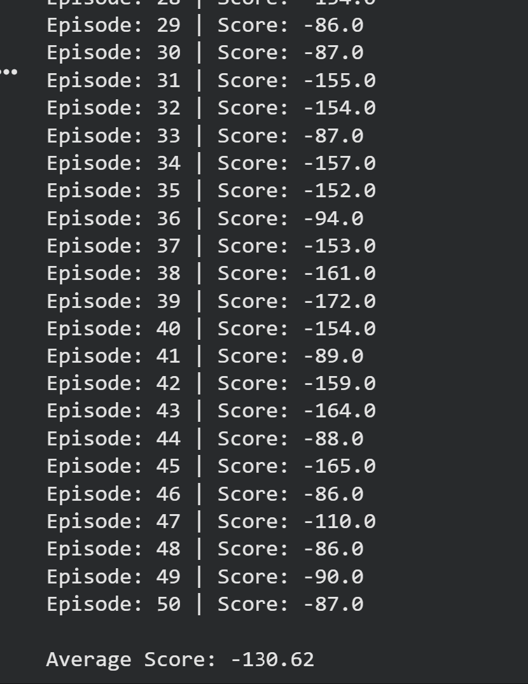

🔹 Task 2: Display State Values
Print the state array in each step and identify:
- Car position
- Car velocity
import gymnasium as gym
env = gym.make('MountainCar-v0')
state, info = env.reset()
for _ in range(100): # Running for 100 steps
# state[0] = Position, state[1] = Velocity
print(f"State Array: {state} | Position: {state[0]:.4f} | Velocity: {state[1]:.4f}")
action = env.action_space.sample()
state, reward, terminated, truncated, info = env.step(action)

if terminated or truncated:
break
env.close()

OUTPUT:
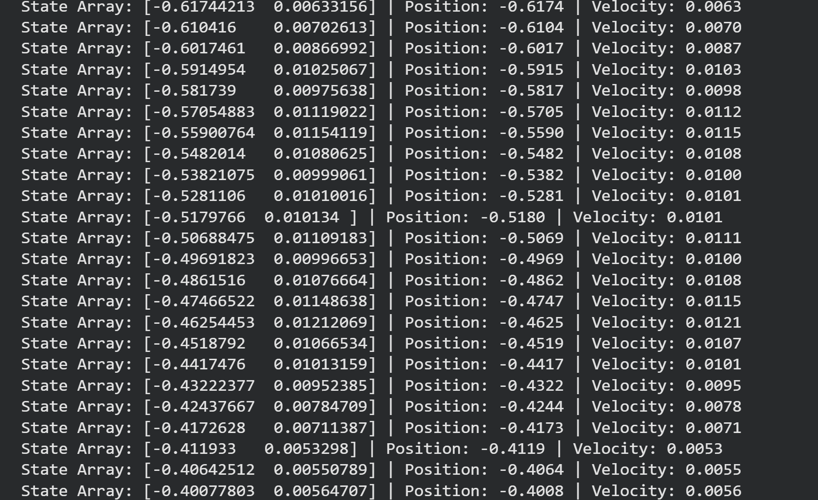

🔹 Task 3: Change Text Color & Location
- Change score color from red to blue
- Display text at position (200, 20)
!pip install gymnasium[classic_control]

import gymnasium as gym
import cv2
import numpy as np
from IPython.display import Image, display
# 1. Setup Environment
env = gym.make('MountainCar-v0', render_mode='rgb_array')
frames = []
print("Starting 50 Episodes...")
# Task 1: Run 50 episodes
for episode in range(1, 51):
state, info = env.reset()
total_reward = 0
terminated = False
truncated = False

while not (terminated or truncated):
# Task 2: Identify Position and Velocity
pos, vel = state[0], state[1]

# We only print the first few steps of Episode 1 to avoid crashing Colab's output
if episode == 1 and total_reward > -5:
print(f"Ep {episode} | Position: {pos:.4f} | Velocity: {vel:.4f}")

# Action: Random sampling
action = env.action_space.sample()
state, reward, terminated, truncated, info = env.step(action)
total_reward += reward

# --- Task 3: Drawing the UI ---
# Only capture frames for the first episode to show as an example
if episode == 1:
frame = env.render()
frame = cv2.cvtColor(frame, cv2.COLOR_RGB2BGR)

# Change color to BLUE (255, 0, 0) and Position to (200, 20)
cv2.putText(frame, f"Score: {int(total_reward)}", (200, 20),
cv2.FONT_HERSHEY_SIMPLEX, 0.6, (255, 0, 0), 2)
frames.append(frame)
if episode % 10 == 0:
print(f"Episode {episode} completed.")
env.close()
# Save the first episode as a GIF to view in Colab
out = cv2.VideoWriter('mountain_car.png', cv2.VideoWriter_fourcc(*'png '), 30, (600, 400))
# Using a simpler display method for Colab: Save one frame as a preview
cv2.imwrite('result_preview.png', frames[50])
print("\nSimulation Finished. Showing a preview frame from Episode 1:")
display(Image('result_preview.png'))

OUTPUT:
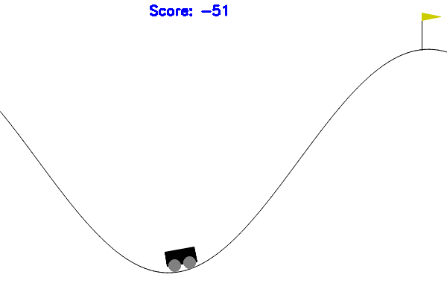

🔹 Task 4: Track Best Performance
- Store the score of each episode
- Print the best (highest) score at the end
import gymnasium as gym
import cv2
import numpy as np
from IPython.display import Image, display
# 1. Setup Environment
env = gym.make('MountainCar-v0', render_mode='rgb_array')
# Task 4 Initialization: Store scores
all_scores = []
best_frame = None
print("Starting 50 Episodes...")
for episode in range(1, 51):
state, info = env.reset()
total_reward = 0
terminated = False
truncated = False
while not (terminated or truncated):
# Task 2: State Identification
pos, vel = state[0], state[1]
# Action: Random sampling
action = env.action_space.sample()
state, reward, terminated, truncated, info = env.step(action)
total_reward += reward
# Capture a frame for visualization (Optional preview)
if episode == 1 and len(all_scores) == 0:
frame = env.render()
frame = cv2.cvtColor(frame, cv2.COLOR_RGB2BGR)
cv2.putText(frame, f"Score: {int(total_reward)}", (200, 20),
cv2.FONT_HERSHEY_SIMPLEX, 0.6, (255, 0, 0), 2)
best_frame = frame
# Task 4: Store score after each episode
all_scores.append(total_reward)
if episode % 10 == 0:
print(f"Episode {episode}/50 - Current Score: {total_reward}")
env.close()
# Task 4: Print the Best Performance
best_score = max(all_scores)
print("\n" + "="*30)
print(f"SIMULATION COMPLETE")
print(f"Best Score (Highest): {best_score}")
print(f"Average Score: {np.mean(all_scores):.2f}")
print("="*30)
# Show preview
cv2.imwrite('best_performance.png', best_frame)
display(Image('best_performance.png'))

OUTPUT:
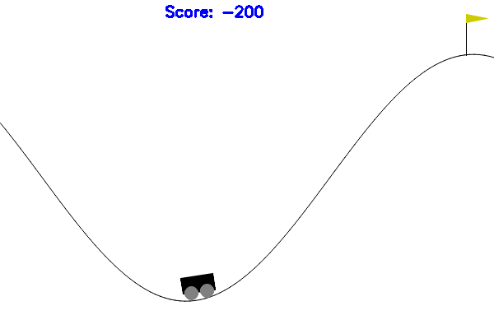

🔹 Task 5: Slow Down Visualization
Add the following line inside the loop:
pygame.time.delay(20)
Observe the change in animation speed.
import gymnasium as gym
import cv2
import numpy as np
import time
from IPython.display import Image, display
#Task: Setup environment for Colab
env=gym.make('MountainCar-v0',render_mode='rgb_array')
all_scores=[]
frames=[]
print("Simulation Start: Running 50 Episodes...")
for episode in range(1,51):
state,info=env.reset()
total_reward=0
terminated=False
truncated=False
while not(terminated or truncated):
#Task 2: Identify Position and Velocity
pos,vel=state[0],state[1]
#Action: Random sampling
action=env.action_space.sample()
state,reward,terminated,truncated,info=env.step(action)
total_reward+=reward
#Task 5: Slow down (Simulated delay)
time.sleep(0.01)
#Task 3: Blue Score (200, 20) - Capture Episode 1 frames
if episode==1:
frame=env.render()
frame=cv2.cvtColor(frame,cv2.COLOR_RGB2BGR)
cv2.putText(frame,f"Score: {int(total_reward)}",(200,20),cv2.FONT_HERSHEY_SIMPLEX,0.6,(255,0,0),2)
frames.append(frame)
all_scores.append(total_reward)
if episode%10==0:
print(f"Episode {episode} Finished. State -> Pos: {pos:.2f}, Vel: {vel:.4f}")
env.close()
#Task 4: Best Performance
print("\n"+"="*20)
print(f"Best Score: {max(all_scores)}")
print(f"Average Score: {np.mean(all_scores)}")
print("="*20)
#Display result
cv2.imwrite('result.png',frames[100])
print("\nPreview of Episode 1 (Blue Score at 200,20):")
display(Image('result.png'))

🔹 Task 6: Compare with CartPole
Replace the environment with:
env = gym.make("CartPole-v1", render_mode="human")
Compare:
- Reward behavior
- Episode termination
- Learning difficulty
import gymnasium as gym
import cv2
import numpy as np
from IPython.display import Image, display
#Task: Setup CartPole-v1
env=gym.make('CartPole-v1',render_mode='rgb_array')
cp_scores=[]
frames=[]
print("Running CartPole-v1 for 50 Episodes...")
for episode in range(1,51):
state,info=env.reset()
total_reward=0
terminated=False
truncated=False
while not(terminated or truncated):
#Task 2 Identify: [Cart Pos, Cart Vel, Pole Angle, Pole Ang Vel]
action=env.action_space.sample()
state,reward,terminated,truncated,info=env.step(action)
total_reward+=reward
if episode==1:
frame=env.render()
frame=cv2.cvtColor(frame,cv2.COLOR_RGB2BGR)
#Task 3: Blue score at (200, 20)
cv2.putText(frame,f"Score: {int(total_reward)}",(200,20),cv2.FONT_HERSHEY_SIMPLEX,0.6,(255,0,0),2)
frames.append(frame)
cp_scores.append(total_reward)
env.close()
print(f"CartPole Best Score: {max(cp_scores)}")
cv2.imwrite('cartpole_result.png',frames[10] if len(frames)>10 else frames[0])
display(Image('cartpole_result.png'))

OUTPUT:
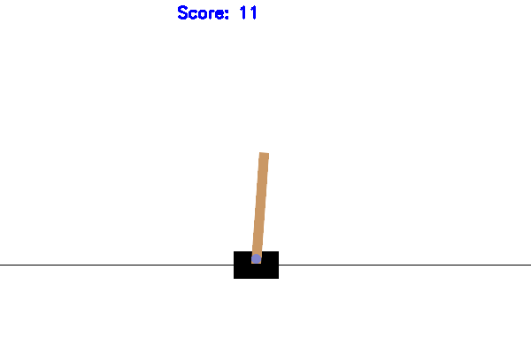

Comparison Analysis
Feature | MountainCar-v0 | CartPole-v1
Reward Behavior | Negative (-1 per step). The agent is punished for time. The goal is to finish as fast as possible. | Positive (+1 per step). The agent is rewarded for survival. The goal is to stay "alive" as long as possible.
Episode Termination | Ends when the car hits the goal (0.5) or hits the 200-step limit. | Ends when the pole falls (angle > 12°) or the cart moves off-screen.
Learning Difficulty | Hard (Sparse Reward). Random actions almost never reach the goal, so the agent receives no positive reinforcement. | Easy (Dense Reward). Even random actions survive for a few steps, giving the agent immediate feedback on what works.

🔹 Task 7: Simple Rule-Based Policy (Intermediate)
Replace random actions with:
if state[1] > 0:
action = 2
else:
action = 0
Observe whether the agent reaches the hilltop.
import gymnasium as gym
import cv2
import numpy as np
from IPython.display import Image, display
env=gym.make('MountainCar-v0',render_mode='rgb_array')
scores=[]
frames=[]
print("Running Rule-Based Policy...")
for episode in range(1,11): #Running 10 episodes to observe success
state,info=env.reset()
total_reward=0
terminated=False
truncated=False
while not(terminated or truncated):
#Task 7: Rule-Based Policy
#state[1] is Velocity
if state[1]>0:
action=2
else:
action=0
state,reward,terminated,truncated,info=env.step(action)
total_reward+=reward
if episode==1:
frame=env.render()
frame=cv2.cvtColor(frame,cv2.COLOR_RGB2BGR)
cv2.putText(frame,f"Score: {int(total_reward)}",(200,20),cv2.FONT_HERSHEY_SIMPLEX,0.6,(255,0,0),2)
frames.append(frame)
scores.append(total_reward)
print(f"Episode {episode} Score: {total_reward} | {'SUCCESS' if terminated else 'FAILED'}")
env.close()
print(f"Best Score with Policy: {max(scores)}")
#Save success frame
if frames:
cv2.imwrite('success_preview.png',frames[-1])
display(Image('success_preview.png'))

🔹 Task 8 (Advanced): Episode Length Analysis
Print the number of steps per episode and analyze:
- Why some episodes last longer
- Relation between steps and score
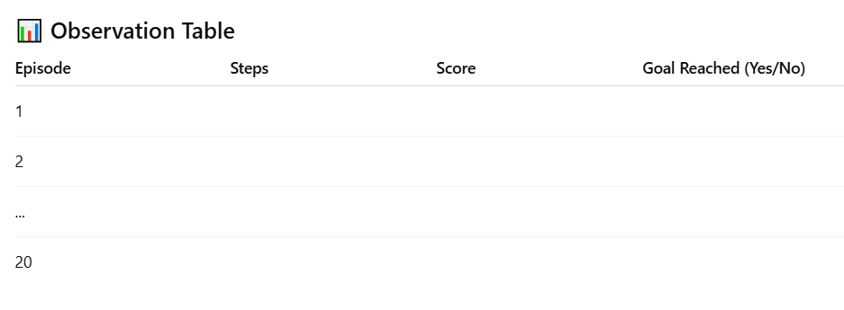

import gymnasium as gym
import numpy as np
env=gym.make('MountainCar-v0',render_mode='rgb_array')
step_counts=[]
all_scores=[]
print("Analyzing 50 Episodes...")
for episode in range(1,51):
state,info=env.reset()
steps=0
total_reward=0
terminated=False
truncated=False
while not(terminated or truncated):
# Using Rule-Based Policy from Task 7 for success data
action=2 if state[1]>0 else 0
state,reward,terminated,truncated,info=env.step(action)
total_reward+=reward
steps+=1
step_counts.append(steps)
all_scores.append(total_reward)
print(f"Ep {episode}: Steps={steps} | Score={total_reward}")
env.close()
print(f"\nMax Steps: {max(step_counts)} | Min Steps: {min(step_counts)}")

Why do some episodes last longer?
- Random Start Position: The environment resets the car to a random position between -0.6 and -0.4 and a velocity of 0.
- Initial Momentum: If the car starts slightly further to the left, it might need one less "swing" to build the momentum required to clear the hill. If it starts closer to the bottom, it might struggle longer to escape the gravity well.
- Phase Alignment: If the initial push doesn't align perfectly with the hill's slope, the first few steps are "wasted," leading to a longer episode.

2. Relation between Steps and Score
The relationship is perfectly linear and negative.
$$Score = -(Steps)$$
- Fixed Penalty: Since the reward is exactly $-1$ per step, there is no way to get a "bonus."
- The Math: If Episode A takes 100 steps, the score is -100. If Episode B takes 200 steps, the score is -200.
- Optimization: In Reinforcement Learning, "maximizing the reward" in this environment is mathematically identical to "minimizing the number of steps."

